**Tree Map**

The tree map displays data in nested rectangles. The dimensions to define the structure of the tree map and measures to define the size or color of the individual rectangle. The rectangles are easy to visualize as both the size and shade of the color of the rectangle reflect the value of the measure.

A Tree Map is created using one or more dimension with one or two measures.

## Creating Tree Map

Using the Sample-superstore, let's plan to find the size of profits for each Ship mode values. To achieve this objective we follow the below steps.

### Step-1

Drag and drop the measure profit two times to the Marks Card. Once to the size shelf and again to the color shelf.

### Step-2

Drag and drop the dimension ship mode to the Label shelf. Choose the chart type Tree Map from Show me. The below chart appears.

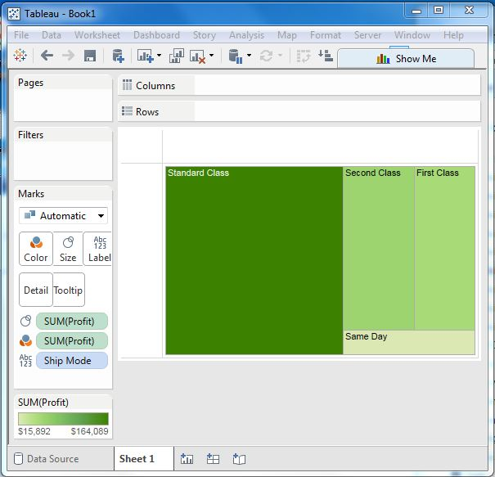

## Tree Map with Two Dimensions

Let’s add the dimension Region to the above Tree map chart. We drag and drop it twice. Once to color Shelf and again to Label shelf. The below chart appears which shows four outer boxes for four regions and then the boxes for ship modes nested inside them. Please note all the different regions have different colors now.

